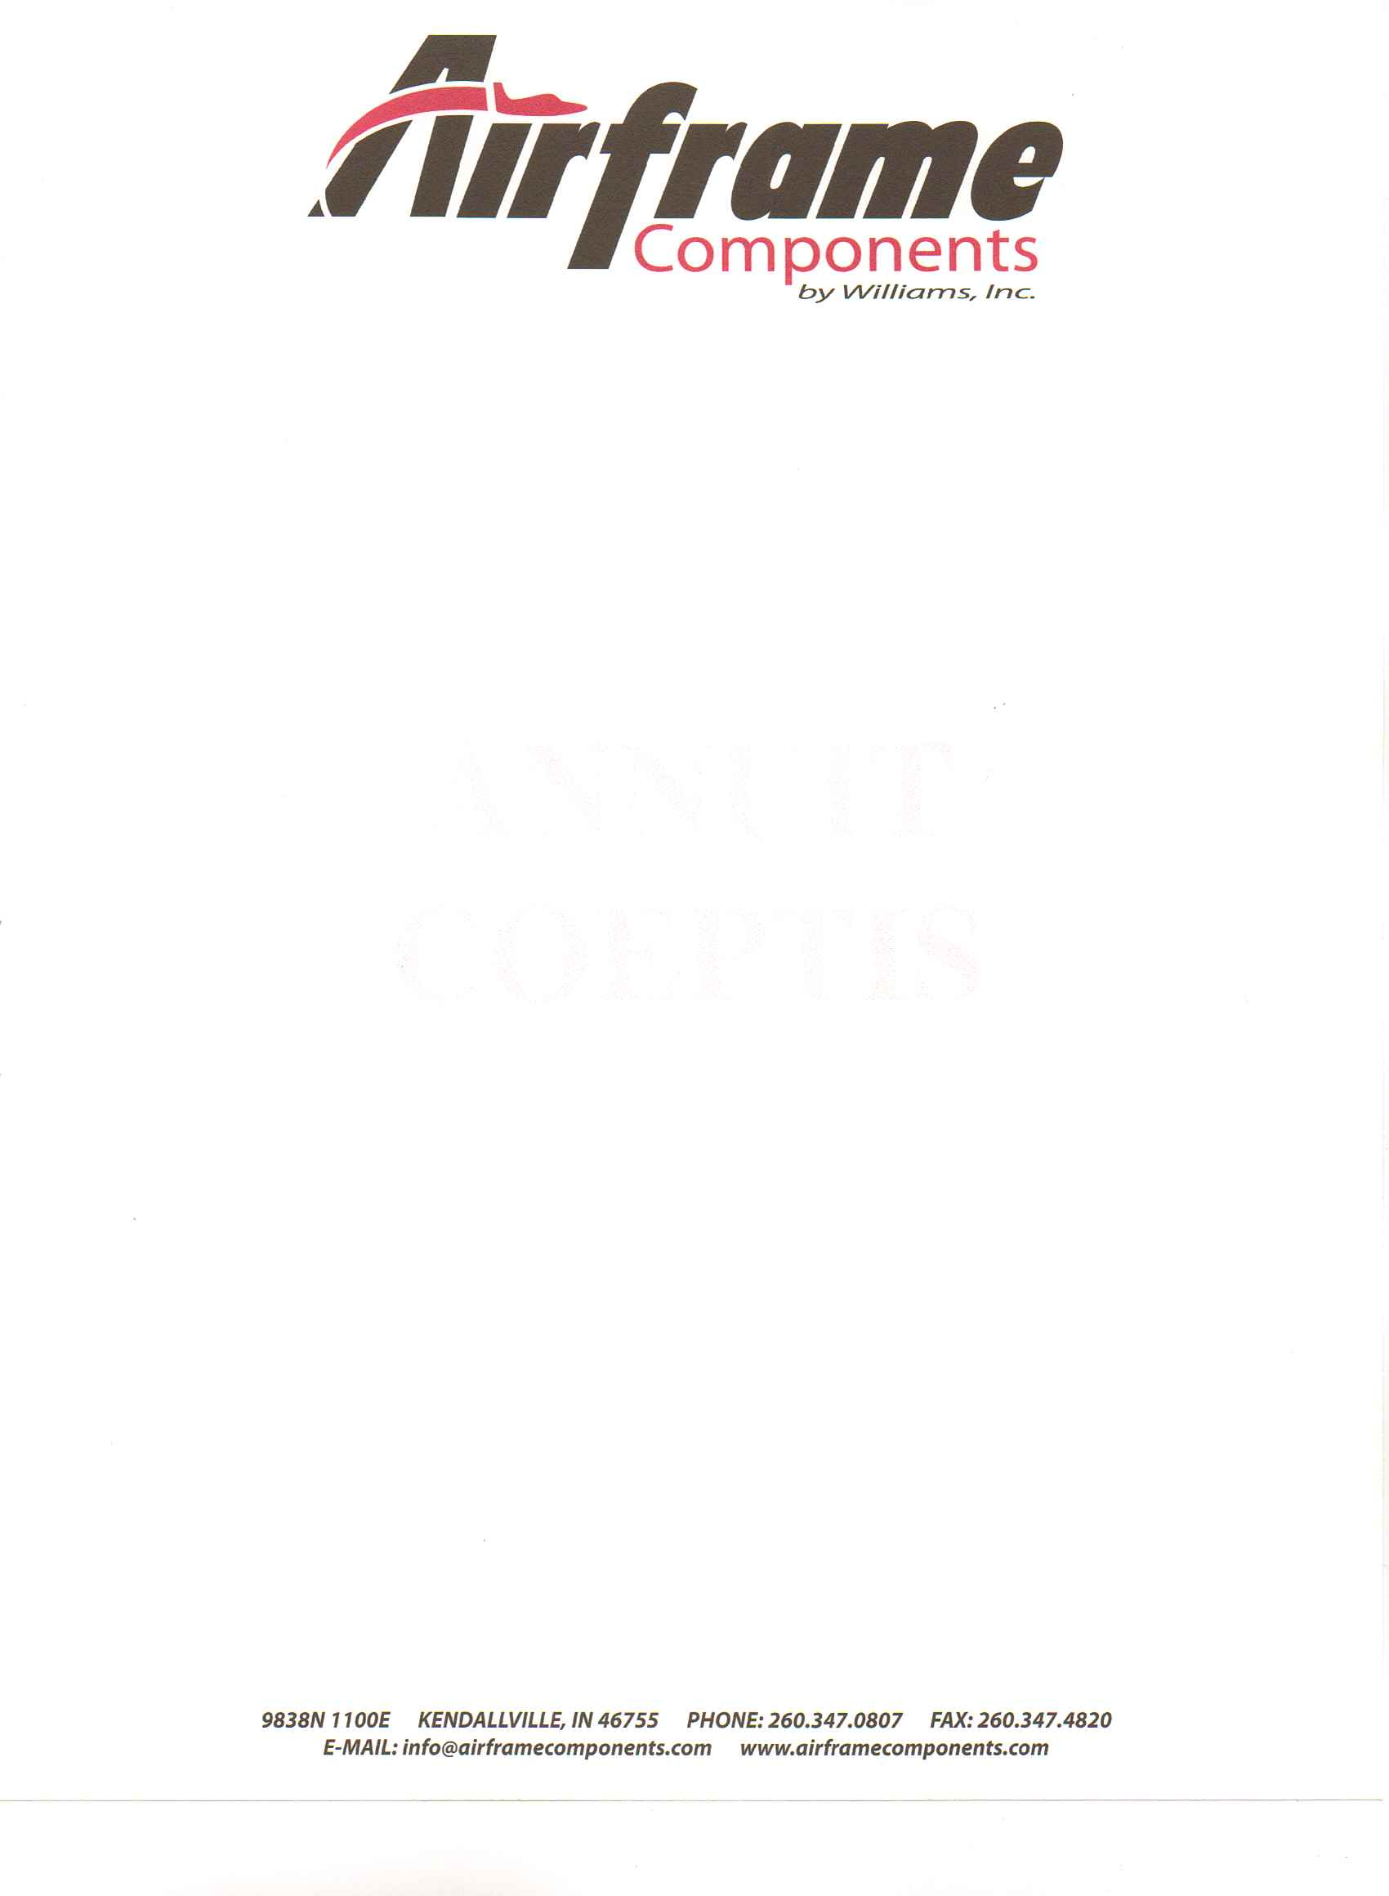
A Signature is Required for all deliveries during regular business hours (Monday‐Friday 8:00AM to 4:00PM). Prior to signing and accepting any freight, please insure it has been carefully
inspected for any damage.
It is the responsibility of the consignee(s) to receive all item(s). The consignee must be present to
receive any item(s) at the time of delivery.

Receiving Delivered Item(s)
The consignee is responsible for the removal of all item(s) from the truck. The truck driver(s) will
position the item(s) in the back of the truck. Driver(s) are not allowed or responsible for
removing delivered item(s). Unless a lift gate service is requested at the time of the order, the
consignee is responsible for handling the item(s) which may require a fork‐lift. If the shipment
can’t be unloaded, and the freight company is requested to return with a lift‐gate equipped
truck, the consignee will be responsible for the cost.

Inspecting Your Shipment
Prior to signing and accepting any freight, please insure it has been carefully inspected for any
damage. It is the consignee’s responsibility to inspect their shipment for any and all damages. If
the packaging shows any indication of damage or mistreatment, please open it immediately and
carefully review its contents. The consignee may ask the driver to aid in the inspection of the
item(s). If the item(s) have been damaged, the consignee (or the driver) must write a precise
description of the damage on both the consignees copy and the freight company’s copy of the
delivery waybill. In the event damaged item(s) are discovered, please call Airframe Components as soon as possible.

Concealed Loss or Damage
Please open and inspect all item(s) within 48 hours of receipt. If concealed
damage is discovered please contact us immediately. Also, please make every
attempt to leave the package, package materials and its contents as you found them when you
first discovered the damage. Please take pictures of damage and e-mail to: karen@airframecomponents.com.
Note: The consignee may refuse any damaged item(s) and the reason must be noted on the waybill.
Thank you for your purchase of aircraft parts from Airframe Components by Williams, Inc.
We try to provide the very best service and quality workmanship.
As you know aircraft parts are fragile and high value.
Therefore, please review the following guidelines when receiving your order.

